CREATE IBM DB2 AND CONNECT WITH PYTHON

|  |  |
| --- | --- |
| DATE | 12 NOVEMBER 2022 |
| TEAM ID | PNT2022TMDI43156 |
| PROJECT NAME | NUTRITION ASSISTANT APPLICATION |

CONNECT WITH DB2 DATABASE

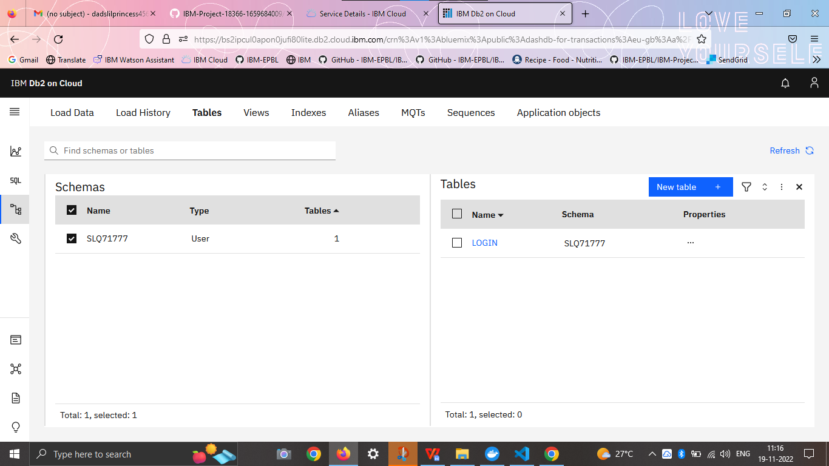

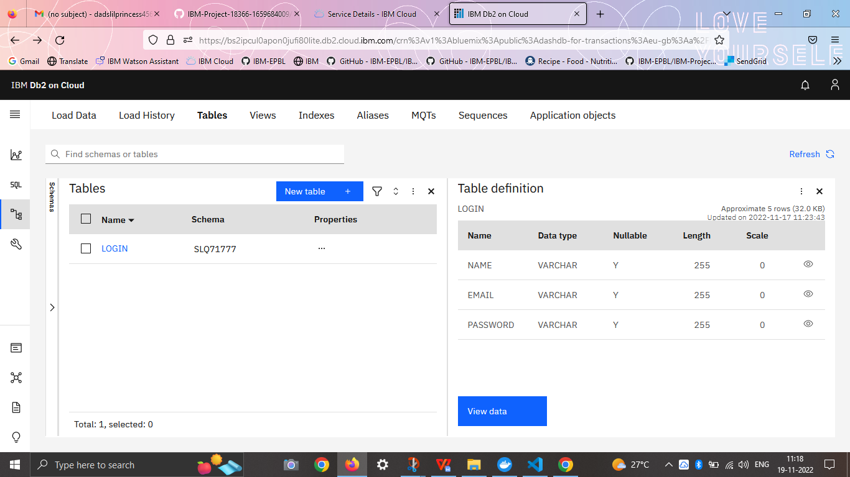

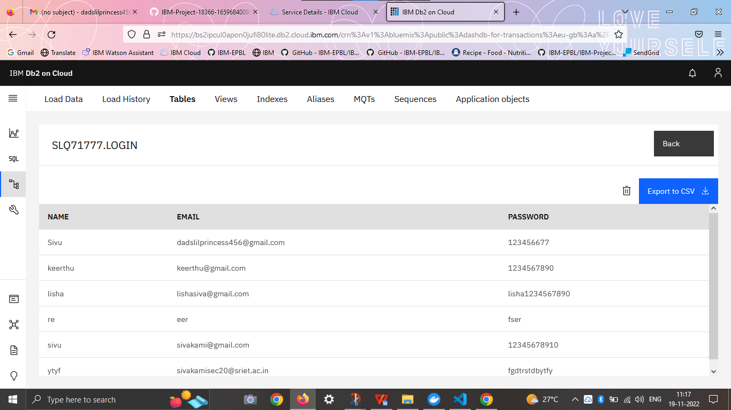

CONNECT DB2 WITH PYTHON

